**DAILY ONLINE ACTIVITIES SUMMARY**

|  |  |  |  |  |  |  |  |  |
| --- | --- | --- | --- | --- | --- | --- | --- | --- |
| **Date:** | **24/07/2020** | | | | | **Name:** | **NAIPUNYA VINOD NAIK** | |
| **Sem & Sec** | **IV SEM & A SECTION** | | | | | **USN:** | **4AL18CS050** | |
| **Online Test Summary** | | | | | | | | |
| **Subject** | | **NO INTERNALS CONDUCTED** | | | | | | |
| **Max. Marks** | | **30** | | **Score** | | | **---------------------------------** | |
| **Certification Course Summary** | | | | | | | | |
| **Course** | 1. **ONLINE WORKSHOP OF PYTHONIC CODING RATHER THAN PYTHON CODING – LOGICAL PERSPECTIVE** 2. **COMPLETE TENSORFLOW LITE COURSE FOR ANDROID APP DEVELOPMENT** | | | | | | | |
| **Certificate Provider** | | | **1) AIET**  **2) UDEMY** | | **Duration** | | | **1) 2.5 HRS**  **2) 4.5 HRS** |
| **Coding Challenges** | | | | | | | | |
| **Problem Statement: DATATYPES PROBLEM STATEMENT** | | | | | | | | |
| **Status: EXECUTED** | | | | | | | | |
| **Uploaded the report in Github** | | | | | **YES** | | | |
| **If yes Repository name** | | | | | <https://github.com/naipunya-naik/Online-Coding-platformcoding/blob/master/Datatypes_Hackerrank_24-07-2020.c> | | | |
| **Uploaded the report in slack** | | | | | **YES** | | | |

Online Test Details: (Attach the snapshot and briefly write the report for the same).

NO INTERNALS CONDUCTED

Certification Course Details: (Attach the snapshot and briefly write the report for the same).

1. **ONLINE WORKSHOP OF PYTHONIC CODING RATHER THAN PYTHON CODING – LOGICAL PERSPECTIVE**
2. TODAY WE ATTENDED THE FOURTH DAY OF 4-DAY PYTHON WORKSHOP.
3. CONDUCTED BY:- DR S.MOHIDEEN BADHUSHA, PROFESSOR, CSE DEPT, AIET.
4. WE HAD 2 SESSIONS ON DAY 4.
5. I EXECUTED WORKED OUT EXAMPLES AND EXERCISES ON GOOGLE COLAB AND POSTED IT ON MY GITHUB REPOSITORY.

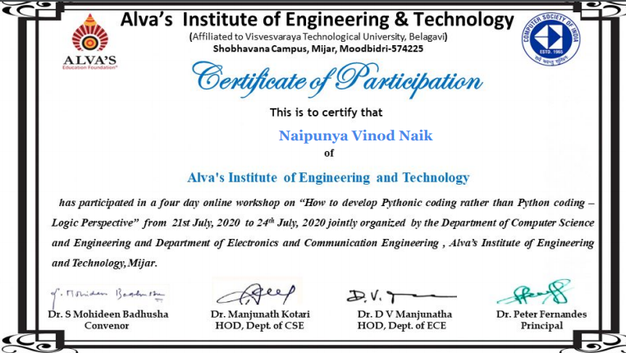

2)CERTIFICATION COURSE NAME:- COMPLETE TENSORFLOW LITE COURSE FOR ANDROID APP DEVELOPMENT

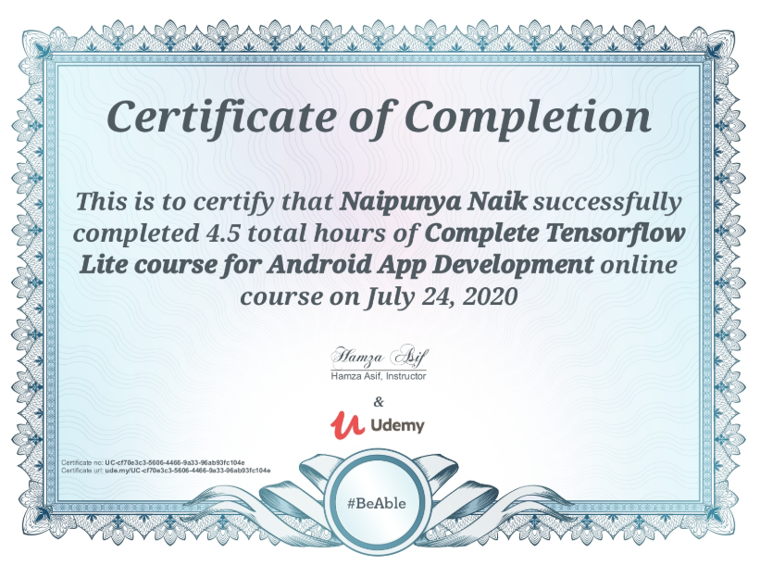

Coding Challenges Details: (Attach the snapshot and briefly write the report for the same).

**Task**  
Complete the code in the editor below. The variables , , and  are already declared and initialized for you. You must:

1. Declare  variables: one of type *int*, one of type *double*, and one of type *String*.
2. Read  lines of input from stdin (according to the sequence given in the *Input Format* section below) and initialize your  variables.
3. Use the  operator to perform the following operations:  
   1. Print the sum of  plus your int variable on a new line.
   2. Print the sum of  plus your double variable to a scale of one decimal place on a new line.
   3. Concatenate  with the string you read as input and print the result on a new line.

**Note:** If you are using a language that doesn't support using  for string concatenation (e.g.: C), you can just print one variable immediately following the other on the same line. The string provided in your editor *must* be printed first, immediately followed by the string you read as input.

**Input Format**

The first line contains an integer that you must sum with .  
The second line contains a double that you must sum with .  
The third line contains a string that you must concatenate with .

**Output Format**

Print the sum of both integers on the first line, the sum of both doubles (scaled to  decimal place) on the second line, and then the two concatenated strings on the third line.

I ATTEMPTED THIS QUESTION AND PASSED TWO TEST CASES.

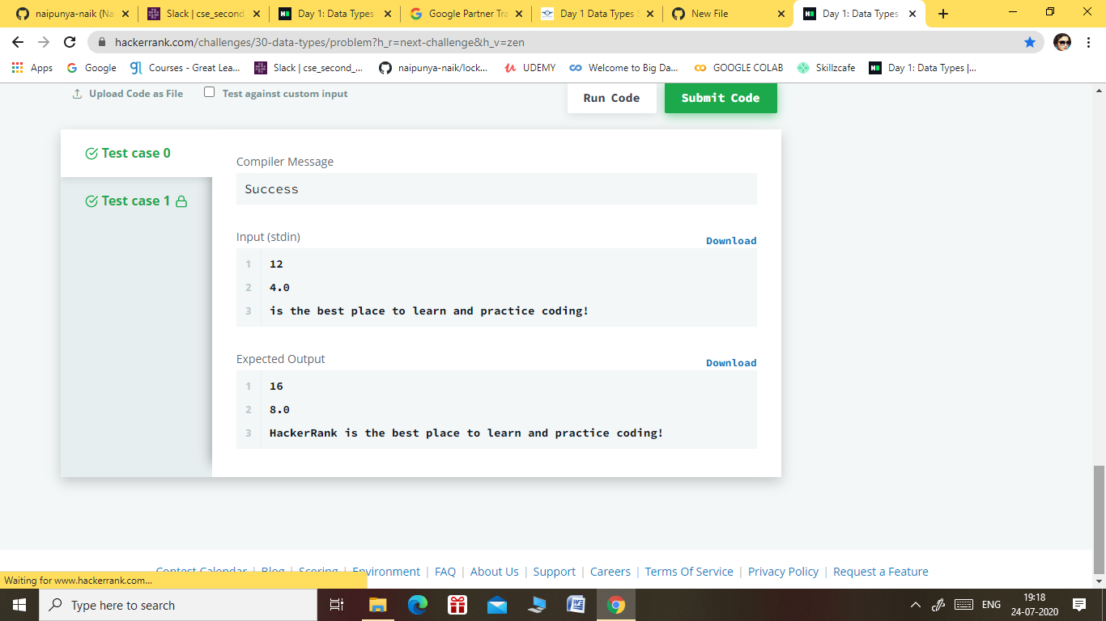

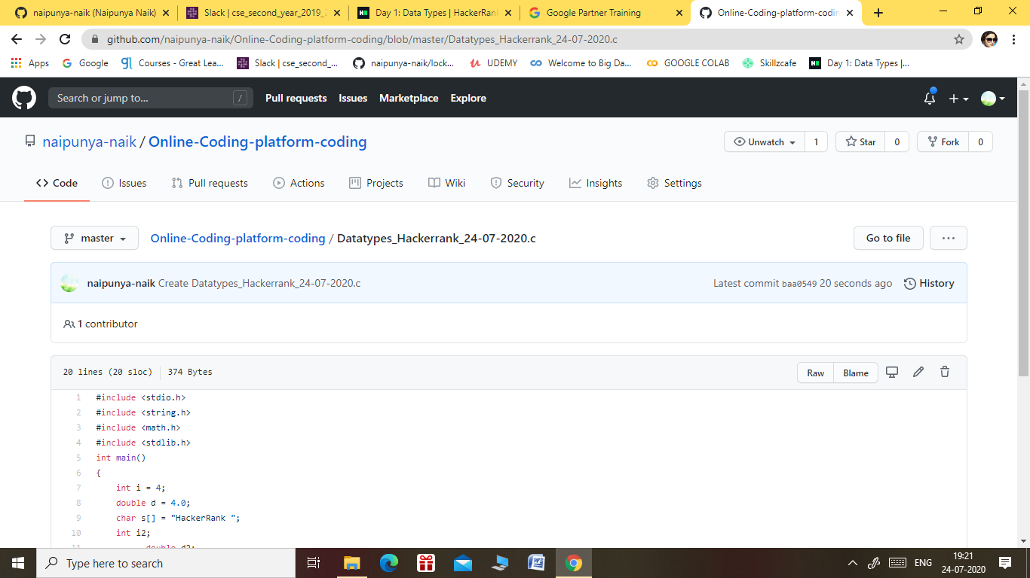

GITHUB REPOSITORY LINK:-

<https://github.com/naipunya-naik/Online-Coding-platform-coding/blob/master/Datatypes_Hackerrank_24-07-2020.c>